**Convalescent plasma could be a life-saving treatment for COVID-19**

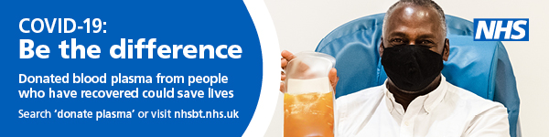

**If you have had COVID-19 you could potentially help other patients fight it by donating your blood plasma**.

NHSBT are currently looking at how the antibodies from blood plasma could support high risk groups such as the elderly and people with cancer who could struggle to develop their own immune response to the virus

Donations are vital to this ongoing lifesaving research, which gives us a better understanding of how we can best treat patients with COVID-19 and help prevent deaths in the future.

If you are male and have received hospital care you are around six times more likely to have the high antibody levels which might save lives.

Making a donation is painless and only takes about 45 minutes and can be undertaken at a nearby donor centre.

Anyone who has had COVID-19 can offer to donate by calling 0300 123 23 23 or completing the online form at [www.nhsbt.nhs.uk](http://www.nhsbt.nhs.uk).