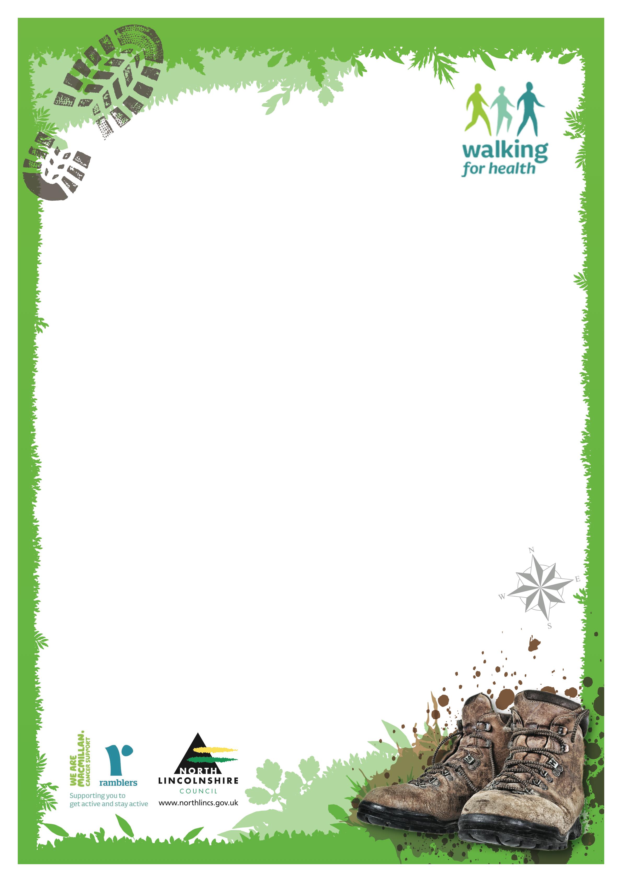
Would you like to set up a walking group in your own area
We are looking for people to set up led walks as Wellbeing Walks of up to 90 minutes .
Ideas :
Photography walks
Local History walks
Parent and toddler walks
Woodland walks, Memory walks
Veteran walks
For more information contact : e mail
christine.johnson@northlincs.gov.uk
Telephone/text ; 07717586380

