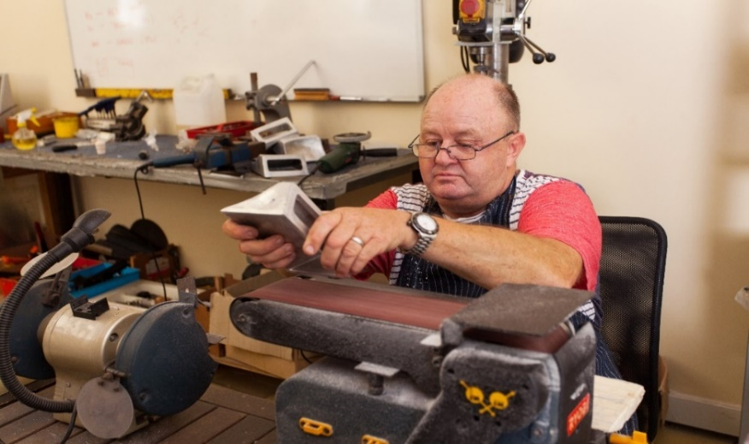
Fancy setting up a Men’s Shed in your area.
Did you know there are over 600 Sheds open in the UK?

Over 14,472 men are benefitting directly from being involved!

Why should people come?

Tell them!

Men in sheds BRIGG
INFORMATION EVENT
Date: 28 July 2021 Time:10am-11.30
Location: The Buttercross, Market Place, Brigg, DN20 8ER
TO FIND OUT MORE ABOUT MEN IN SHEDS AND HOW YOU CAN GET INVOLVED, HWRA INVITES YOU TO JOIN US AT OUR INFORMATION EVENT TO BE HELD AT THE BUTERCROSS, MARKET PLACE BRIGG.
To book a place at the event or for further information please contact us via email or telephone.
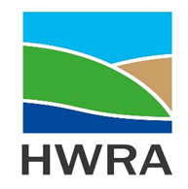
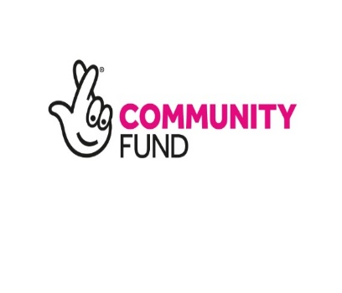
For further information contact Carole Johnson carole.johnson@hwrcc.org.uk Tel: 07983479362 or for bookings contact Julie Cook Email: julie.cook@hwrcc.org.uk Tel: 01652 637700.

About Men’s Sheds
They are community spaces for men to connect, converse and create. The activities are often like those, of garden sheds, but for groups of men to enjoy together. They help reduce loneliness and isolation, but most importantly, they are fun!
HWRA is funded by the Lottery Community Fund to facilitate the development of Men’s Sheds in Northern Lincolnshire.

