PROTECT yourself from becoming a VICTIM of FRAUD

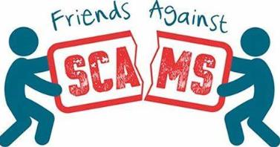
Sign up for online training

www.friendsagainstscams.org.uk/training/friends-elearning

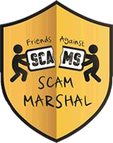
Become a Scam Marshal www.friendsagainstscams.org.uk/scammarshals

Keep up to date with the latest information from Action Fraud.

www.actionfraud.police.uk

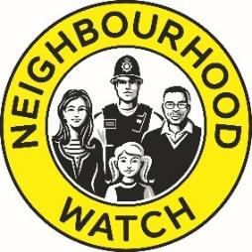
Form a Neighbourhood Watch Email – saferneighbourhoods@northlincs.gov.uk
Tel: 01724 297432

www.actionfraud.police.uk | www.citizensadvice.org.uk | www.ageuk.org.uk

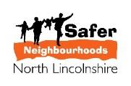
https://www.friendsagainstscams.org.uk/ | https://www.saferneighbourhoods.net/

If you or someone else is in immediate danger or risk of harm dial 999 now.

